**EEE361**

**ASSIGNMENT**

**SET-8**

1. The magnetic field in a region is given by the expression

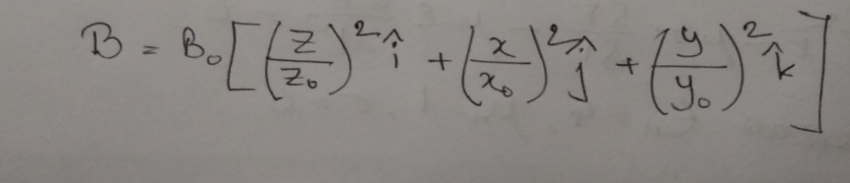

* 1. Using the knowledge of Maxwell’s equation, find the curl of the induced electric field at that location.
  2. The electric field has 3 components, Ex (in the direction of x0-,Ey (in the direction of y), Ez (in the direction of z). Using the result from part (a), find the x component of the electric field if the y component is assumed to be zero.

1. (a) In free space, the electric filed is defined by

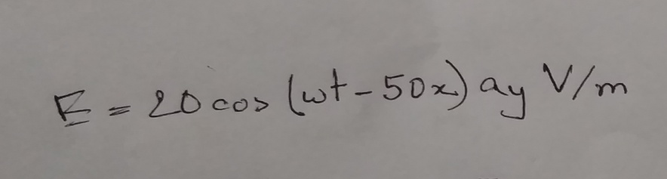

Using the knowledge of Maxwell’s equation calculate

* 1. Displacement current density, Jd
  2. Magnetic field intensity, H

(b) **(**i) We know that: Maxwell’s 4th law [known as Ampere’s law] has a quantity: electric conducting current. Now, explain**:** **why there is no magnetic conducting current** in the 3rd law of Maxwell’s Electromagnetic equation, known as Faraday’s law. Explain.

(ii) Why an Electromagnetic wave is expressed as a Cosine wave even though the electric and magnetic fields are round shaped closed lines. Please explain in detail.

1. a) In air , the electric filed intensity is

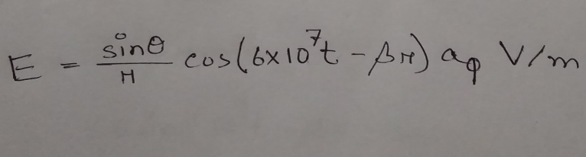

Using this information and Maxwell’s equation find magnetic field intensity, H and the constant β. (This is in spherical coordinate system. You can use internet to understand the coordinate calculation).

b) In air ,the electric field is defined by

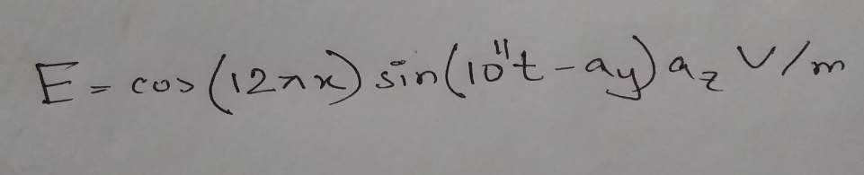

Using this information and Maxwell’s equation, find magnetic field intensity, H   
  
 C) (ii) Why is there a ‘negative’ sign in the Continuity Equation? Exaplain with proper figures.

1. (i) A source free ‘lossy’ region is a region, where there is no net charge and no current. Rewriting the Maxwell ‘s equations accordingly show that in a source free ‘lossy’ region, the wave equation becomes:

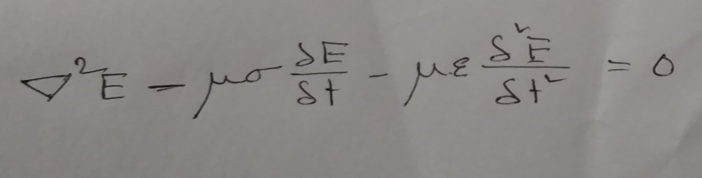

(ii) Given, $\overline{E}$ = 25 sin (2π×106 t – 6x) z V/m.

* Find direction of the propagation of wave
* Calculate time period, wave length, velocity
* At t = 0, T/8, T/4, T/2 sketch the wave shapes

1. In a dielectric medium (ε = 9 ε0, µ = µ0), a plane wave with magnetic field,

$$H = 0.2 cos ({10}^{9}t- kx-k\sqrt{8z} ) a_{y} A/m$$

Is incident on an air at z = 0 find

a. $θ_{r} and θ_{t}$

b. k of incident, transmitted and reflected fields

c. The incident, transmitted and reflected **H**

d. The Incident, transmitted and reflected **E**

